光伏系统用铜芯无卤电缆
Copper core halogen-free cable for Photovoltaic system
产品型号Product name: EN H1Z2Z2-K
产品认证 Approvals: TUV Rheinland/Dekra EN50618-2014 H1Z2Z2-K 1.5mm²-35mm²
产品结构Cable structure:
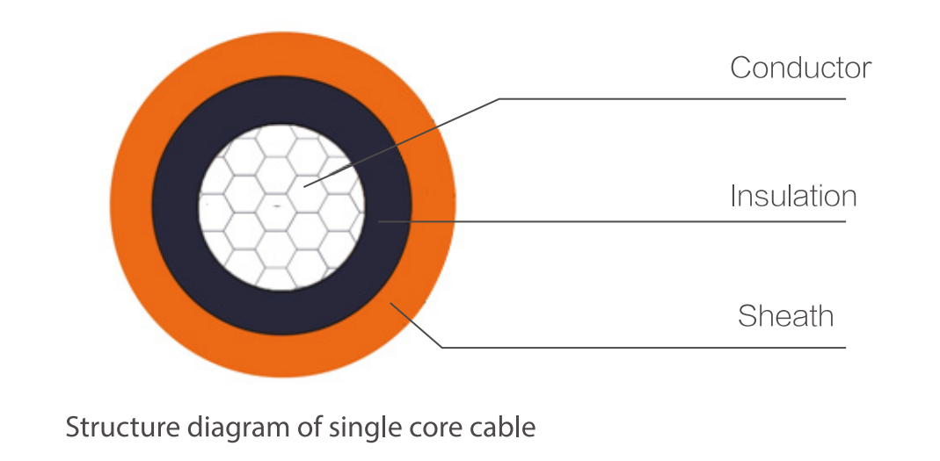
常用参数 Common Parameters:
导体截面  Cross Section (mm²) | 导体结构  Conductor Construction (n/mm) | 导体绞合外径  Conductor Stranded OD. （mm） | 成品近似外径  Cable appr. OD. (mm) | 导体直流电阻  Conductor Max. Resistance @20℃（Ω/km） | 载流量  Current Carrying Capacity @60℃（A）
1.5 | 30/0.25 | 1.58 | 4.90 | 13.7 | 30
2.5 | 49/0.25 | 2.02 | 5.40 | 8.21 | 41
4 | 56/0.285 | 2.50 | 6.00 | 5.09 | 55
6 | 84/0.285 | 3.17 | 6.30 | 3.39 | 70
10 | 84/0.40 | 4.56 | 8.00 | 1.95 | 98
16 | 126/0.40 | 5.60 | 9.60 | 1.24 | 132
25 | 192/0.40 | 6.95 | 11.40 | 0.795 | 176
35 | 276/0.40 | 8.74 | 13.20 | 0.565 | 218
*此载流量为电缆单根敷设于空气中的情况
The current-carrying capacity is under the situation of laying the single cable in air.

技术参数 Technical Data:
额定电压Nominal voltage：1.0/1.0KV AC, 1.5KV DC
成品电压测试 Voltage test on completed cable: 6.5KV AC, 15KV DC, 5min
环境温度Ambient temperature: -40℃~+90℃
导体最高温度Max. Temperature of conductor: +120℃
使用寿命Service life: ≥25 years (Ambient temperature: -40℃~+90℃)
参考短路允许温度Short circuit allowed temperature refer to: 200℃ in 5 seconds
弯曲半径Bending radius: ≥4×φ (D<8mm), ≥6×φ (D≥8mm)
耐酸碱测试Acid & Alkaline resistance: EN60811-404
冷弯测试Cold bending test: EN60811-504
耐候/紫外线测试Weathering/UV resistance: EN50618
耐臭氧测试O-zone resistance: EN50396
耐穿透性Penetration resistance: Accord with EN50618
无卤阻燃测试Halogen-free flame retardant test: Refer to 2PfG 1169/08.2007, EN50618, IEC60332-1, IEC61034, UL1581 VW-1, etc

