光伏系统用铜芯无卤电缆
Copper core halogen-free cable for Photovoltaic system
产品型号Product name: Double parallel PV cable
产品认证 Approvals: CEEIA B218-2012 2×1.5mm²-16mm² (Multiple color)
产品结构Cable structure:
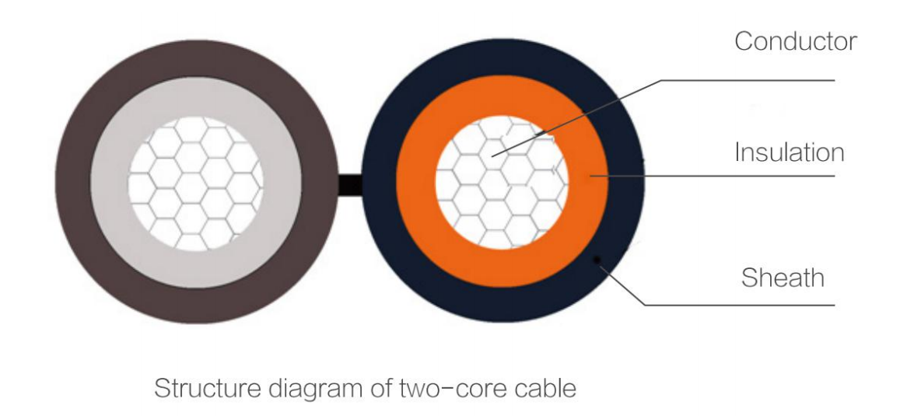
常用参数 Common Parameters:
导体截面  Cross Section (mm²) | 导体结构  Conductor Construction (n/mm) | 导体绞合外径  Conductor Stranded OD. （mm） | 成品外径  Cable OD. (mm) | 导体直流电阻  Conductor Max. Resistance @20℃（Ω/km） | 载流量  Current Carrying Capacity @60℃（A）
1.5 | 30/0.25 | 1.58 | 4.60×9.40 | 13.7 | 30
2.5 | 49/0.25 | 1.98 | 5.10×10.40 | 8.21 | 41
4 | 56/0.285 | 2.35 | 5.50×11.20 | 5.09 | 55
6 | 84/0.285 | 3.06 | 6.20×12.60 | 3.39 | 70
10 | 84/0.40 | 3.92 | 7.50×15.20 | 1.95 | 98
16 | 128/0.40 | 5.58 | 9.30×18.80 | 1.24 | 132
*此载流量为电缆单根敷设于空气中的情况
The current-carrying capacity is under the situation of laying the single cable in air.

技术参数 Technical Data:
额定电压Nominal voltage: 0.6/1.0KV AC, 1.5KV DC
成品电压测试 Voltage test on completed cable: 6.5KV AC, 15KV DC, 5min
环境温度Ambient temperature: -40℃~+90℃
导体最高温度Max. Temperature of conductor: +120℃
使用寿命Service life: ≥25 years (Ambient temperature: -40℃~+90℃)
参考短路允许温度Short circuit allowed temperature refer to: 200℃ in 5 seconds
弯曲半径Bending radius: ≥4×φ (D<8mm), ≥6×φ (D≥8mm)
耐酸碱测试Acid & Alkaline resistance: EN60811-2-1
冷弯测试Cold bending test: EN60811-1-4
耐候/紫外线测试Weathering/UV resistance: HD605/A1
耐臭氧测试O-zone resistance: EN50396
耐穿透性Penetration resistance: Accord with 2PfG 1169/08.2007
无卤阻燃测试Halogen-free flame retardant test: Refer to 2PfG 1169/08.2007, EN50618, IEC60332-1, IEC61034, UL1581 VW-1, etc

