光伏系统用铜芯无卤电缆
Copper core halogen-free cable for Photovoltaic system
产品型号Product name: UL PV
产品认证 Approvals: UL4703 PV 18AWG-2AWG
产品结构Cable structure:
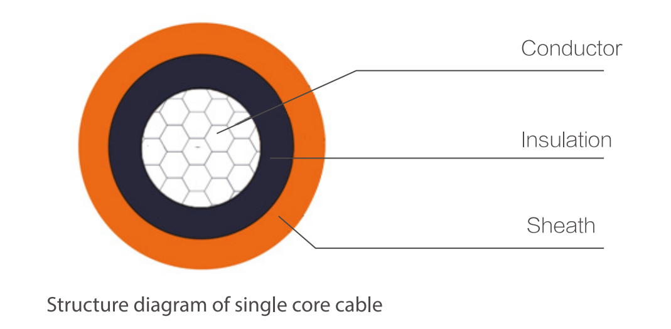
常用参数 Common Parameters:
导体截面  Cross Section (AWG) | 导体结构  Conductor Construction (n/mm) | 导体绞合外径  Conductor Stranded OD. （mm） | 600V  成品外径  Cable OD. (mm) | 1KV/2KV成品外径Cable OD. (mm) | 导体直流电阻  Conductor Max. Resistance @20℃（Ω/km） | 载流量  Current Carrying Capacity @60℃（A）
18 | 16/0.254 | 1.18 | 4.25 | 5.00 | 23.20 | 6
16 | 26/0.254 | 1.49 | 4.55 | 5.30 | 14.60 | 6
14 | 41/0.254 | 1.88 | 4.95 | 5.90 | 8.96 | 6
12 | 48/0.30 | 2.36 | 5.40 | 6.20 | 5.64 | 6
10 | 105/0.254 | 3.00 | 6.20 | 7.05 | 3.546 | 7.5
8 | 168/0.254 | 4.10 | 7.90 | 8.70 | 2.23 | 7.5
6 | 266/0.254 | 5.20 | 9.80 | 10.30 | 1.403 | 7.5
4 | 420/0.254 | 6.50 | 11.50 | 11.60 | 0.882 | 7.5
2 | 665/0.254 | 8.25 | 13.30 | 13.40 | 0.5548 | 7.5
*此载流量为电缆单根敷设于空气中的情况
The current-carrying capacity is under the situation of laying the single cable in air.

技术参数 Technical Data:
额定电压Nominal voltage：600V, 1000/2000V AC
成品电压测试 Voltage test on completed cable:
U=600V: 18~10AWG, U₀=3000V, 50HZ, 1Min；8~2AWG, U₀=3500V, 50HZ, 1Min.
U=1000/2000V: 18~10AWG, U₀=6000V, 50HZ, 1Min；8~2AWG, U₀=7500V, 50HZ, 1Min.
环境温度Ambient temperature: -40℃~+90℃
导体最高温度Max. Temperature of conductor: +120℃
相对介电常数Relative permittivity: UL854
冷弯测试Cold bending test: UL854
耐日光测试Sunlight resistance: UL2556
阻燃测试Flame retardant test: UL1581 VW-1

